|  |  |  |  |  |
| --- | --- | --- | --- | --- |
| **Role Applied for:** | Frontend Developer | **Name of Candidate:** | Abdullah Mahmoud Salem | |
| **Role Location:** | Amman, Jordan | **Nationality:** | Jordanian | |
| **Current Location:** | Amman, Jordan | **Date of Birth & Age:** | 05/01/1990 | |
| **Current Title:** | Software Engineer | | | |
| **Reporting to:** | Mohannad Khasawneh | | | |
| **Titles of Direct Reportees:** | Software Development Manager | | | |
| **Overall Team Size:** | >25 | | | |
| **Total years of experience:** | 6 | | | |
| **Current and Previous Employer Details** *(Please start with current/last employer)* | | | | |
| **Employers Name** | **Title** | **From-To ( Years)** | **Company Size ( Staff)** | |
| **Atypon** | Software Engineer | Sept, 2017 - Current | >250 | |
| **iHorizons, Doha** | Frontend Developer | Mar, 2015 - Aug, 2017 | >30 | |
| **iHorizons, Amman** | Frontend Developer | Mar, 2014 - Mar, 2015 | >100 | |
| **ReserveOut** | Web Developer | Jan, 2012 - Jan, 2013 | <10 | |
|  |  |  |  | |
| **Program/Course (Graduation/PG/Cert :)** | **Institute and Location** | **Full-time/On-Campus ( Yes/No)** | **Duration** | **Year of Completion** |
| BSc in Computer Information Systems | Al Balqa’ Applied University, Salt - Jordan | Full-time | 4 years | 2014 |
|  |  |  |  |  |
|  |  |  |  |  |
|  |  |  |  |  |
|  |  |  |  |  |
| **Current Compensation**  **( Local Currency)** | Fixed Monthly take home ( after all deductions) | |  | |
| Deductions ( monthly) | |  | |
| List of all non-cash benefits | |  | |
|  | |
|  | |
|  | |
|  | |
|  | |
| **Expected Compensation (Local Currency)** | Monthly expected compensation | |  | |
| **Notice Period** | Notice Period as per current contract | | 30 Days | |
| Minimum time required to join | | 20 Days | |
| Provision for notice buy out ( yes/no) | | No | |

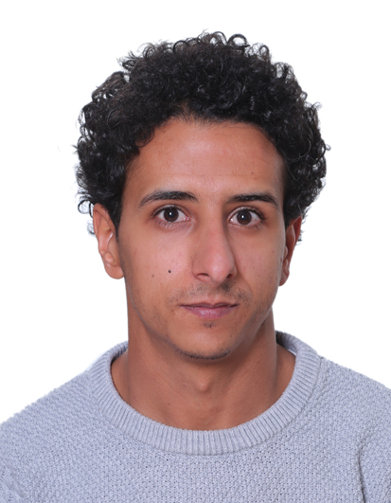

**Recruiters Notes**

|  |  |  |
| --- | --- | --- |
| **Probe area** | **Yes/No** | **Comments ( If any)** |
| Is the candidate currently unemployed? | No |  |
| Does the candidate have any gaps in his/her employment? |  |  |
| Is the candidate’s area of studies relevant to the role? | Yes |  |
| Is the candidate’s expected salary within our budget? | Yes | I expect to get at least the same salary I’m getting currently with Atypon |